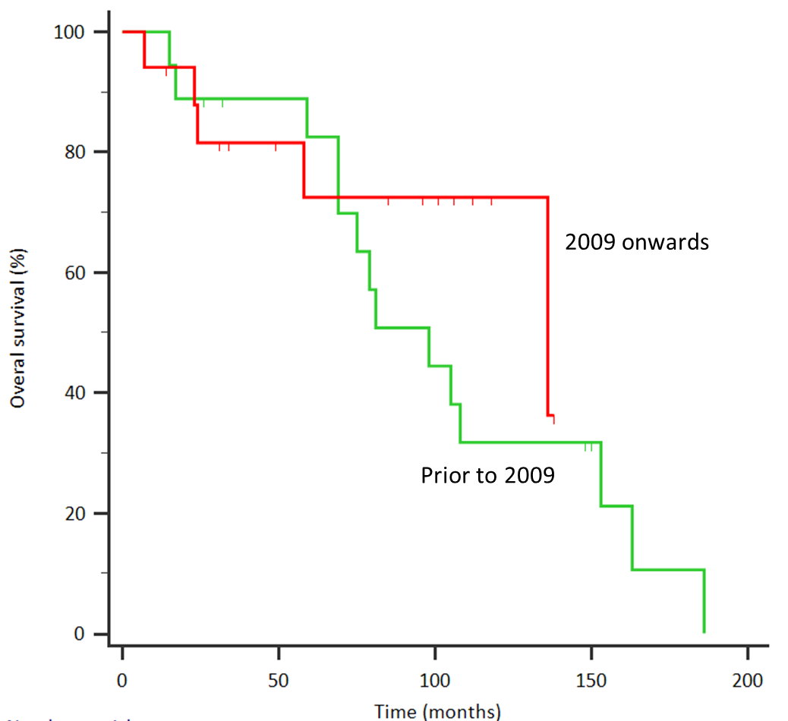
Supplementary Figure 3. Overall survival of R/R MCL patients according to year of diagnosis. Median overall survival was 136 months (2009 onwards; n = 17) compared to 98 months (prior to 2009; n = 18) (HR 0.63, 95% CI 0.23 to 1.73, p = 0.373).

