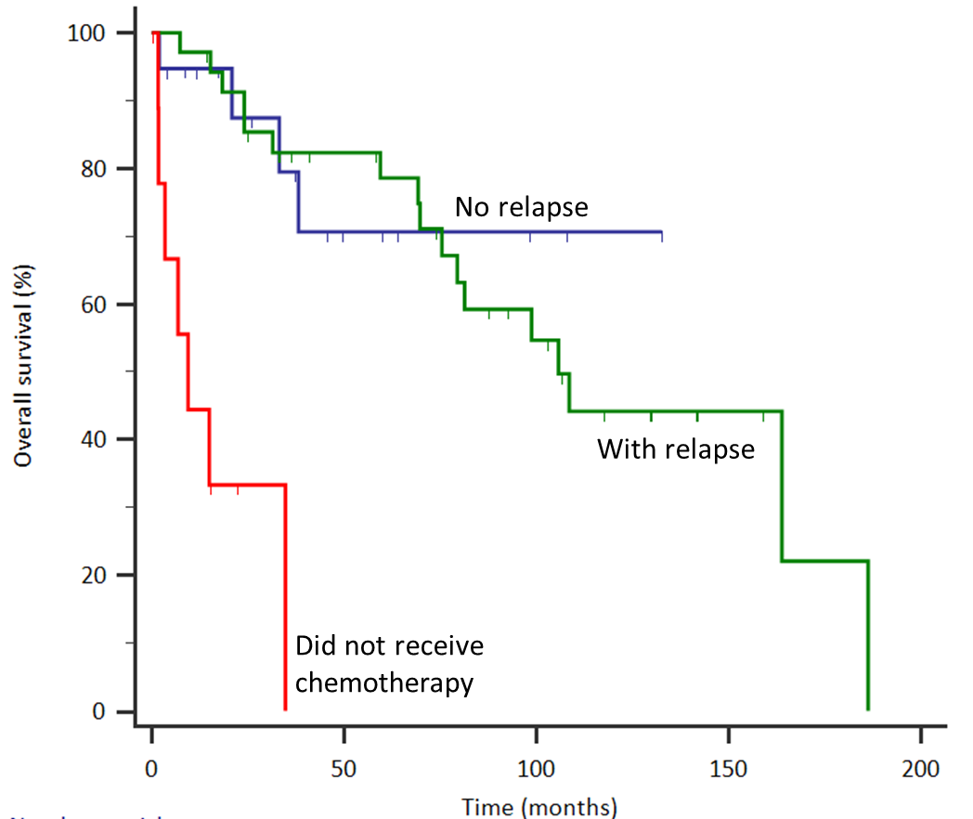
Supplementary Figure 2. Overall survival of patients with (n = 35) or without (n = 19) documented relapse after first-line treatment. Median overall survival was 105 months for the relapsed group, while that was not reached for patients without documented relapse (HR 1.13,
95% CI 0.38 to 3.35, p = 0.823). Survival of patients who did not receive first-line chemotherapy (n = 10) is also shown here for comparison (median, 9.4 months).

